TITLE OF PAPER
[UPPER CASE LETTERS]
First name Last name^{1*}, First name Last name², First name Last name³[Author Name]
1*Affiliation name, institute, email address [Corresponding Author info]
2Affiliation name, institute, email address [Author info]
3Affiliation name, institute, email address [Author info]

Abstract: These guidelines provide instructions to format your Full paper. Please write directly into the template or copy your finished text into it choosing ‘match destination formatting’. Please use the predefined formatting styles instead of applying your individual settings. The full paper should be written in compliance with these instructions. An abstract is not merely a summary but a concise and structured representation of the key aspects of a study. It should be a single paragraph with maximum of 300 words. It should follow the style of structured abstracts. You must include the background, and the research question(s) addressed methodology, results, main conclusions and significance of the study. The abstract should objectively represent the article. Do not include any results that are not presented and supported in the main Abstract. [This paragraph is formatted as Abstract]
Keywords: Maximum 5 keywords; each keyword must be separated by a semicolon, example First keyword; Second keyword; Third keyword [the keywords are formatted as Keywords]

Introduction [this is formatted as Heading 1]

It is expected that authors will submit carefully written and proofread material. Careful checking for spelling and grammatical errors should be performed. The purpose of the introduction is to stimulate the reader’s interest and to provide background information relevant to the study. Explain the broad theme/topic of your study in an opening paragraph in such a way that the reader can clearly understand what the study is about. Explain the academic and practical importance of the study. Compile the available literature by synthesizing the existing knowledge instead of summarizing and citing the most important previous studies which are directly relevant to your research problem. Highlight the important gaps and inconsistencies based on the existing literature, which needs further investigation. If it is relevant specify the objectives of your research with no more than three objectives towards the end of the introduction. [Paragraph]

Materials and Methods
This section describes in detail how the study was conducted, including important definitions and equations used in the study. The research design, sampling methods, methods of data collection, and analysis should be given in this section. Subheadings can be used in this section.
Results
Use a separate results section. Split this section into several sub-sections directed by subheadings to improve readability. Before writing this section, it is important to plan which results are important to the relevant study and which can be left out. Results can be shown either in Tables or Figures. Each figure should be numbered (Figure1, Figure 2…….) with the given caption below the figure. Tables should be numbered (Table 1, Table 2, Table 3…) with the title. Data in tables and figures should not be duplicated. After presenting the results, carefully evaluate and interpret their implications for the objectives of the study.
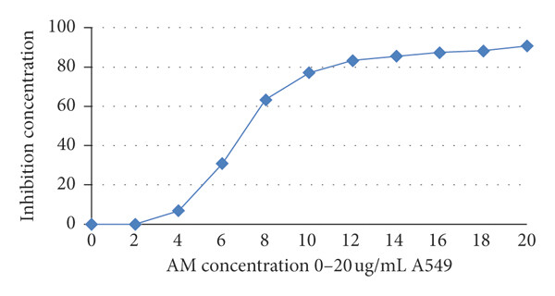
Figure 1: Dose response curve of A. malaccensis extract against different cell lines.
Figure 1Captions are placed under the pictures. Ensure that your caption adequately describes what you want your reader to see in the picture, highlighting any areas that they should focus on or relationships that you might want them to see. [Caption].

Table 4: Colour changes of storage of chicken meat at 4 C
Parameters* | Treatments | Colour changes after stored at 4 ºC
Parameters* | Treatments | 3days | 9days
L | Control | 2.65±0.86 | 3.43±0.05
 | Spice | 2.247±0.99 | 3.87±1.00
a | Control | 1.78±0.97 | 7.33±0.97
 | Spice | 4.25±0.24 | 2.25±0.28
b | Control | 2.65±0.86 | 2.65±0.86
 | Spice | 2.65±0.86 | 2.65±0.86

Discussion
The discussion section in a research paper interprets and analyses the study's results, explaining their significance, implications, and relevance in the broader context of the research field. This section goes beyond merely presenting findings—it critically evaluates them, compares them with previous studies, and discusses limitations and future research directions. Relevant references should be included.
Conclusion
The main conclusion/s should be presented first followed by any other minor conclusions in decreasing order of importance. In this section, you may also emphasize the contribution of your study to the betterment of humanity.
Acknowledgment
Briefly acknowledge any funding, administrative and technical support, or donations in kind (e.g., materials used for experiments).
References
● A maximum of 15 references can be included at the end of the paper.
● Reference list entries must be in line with the APA 7th edition style of referencing (https://apastyle.apa.org/). Papers for the Track of Law shall follow OSCOLA Referencing 4th edition.

References [please choose reference list (APA referencing style)]
[For an article in a journal] Smith, J. A., & Lee, K. M. (2022). Urban forestry practices in South Asia. Journal of Environmental Studies, 45(2), 134–150. https://doi.org/10.1016/jes.2022.03.005.
[Book] Silva, R. M. (2020). Silva, R. M. (2020). Sustainable forestry in South Asia. Green Earth Publishers.
[Chapter in a book] Fernando, A. B. (2021). Community participation in forest conservation. In S. K. Perera & L. J. Fernando (Eds.), Tropical forest management in South Asia (pp. 75–92). EcoScience Publications.
[Report, proceedings (a)] Food and Agriculture Organization. (2020). Global forest resources assessment 2020: Main report (FAO Forestry Paper No. 184). FAO. https://www.fao.org/documents/card/en/c/ca9825en
Jayasinghe, M. T., & Perera, D. S. (2023). Application of remote sensing in forest monitoring. In R. Liyanage & T. Gunarathna (Eds.), Proceedings of the 8th International Symposium on Environmental Sciences (pp. 45–52). University of Ruhuna
[unpublished literature (b)] De Silva, N. A. (2021). Impact of invasive species on forest biodiversity in Sri Lanka (Unpublished master's thesis). University of Peradeniya.
[unpublished manuscript (c)] Perera, S. K. (2023). Draft policy framework for sustainable agroforestry [Unpublished manuscript]. Sri Lanka Council for Agricultural Research Policy.
[Newspaper or magazine] Jayasuriya, H. D. (2023, March 5). Tree planting drive launched in Colombo. Sunday Times, p. A4.
[Internet source (with title, date of access and the universal resource locator in full)] UNO, Charter of the United Nations (Preamble), Date of access: 21/11/2012. http://www.un.org/en/documents/charter/preamble.shtml.
[Government legislation (a)] US CONGRESS, Senate Committee on Foreign Relations, 1956, The Mutual Security Act of 1956, 84th Congress, second session, report 2273.

Special Note:
This template document itself uses the same formatting as required for the Conference therefore; your full paper should appear visually very similar. Do not change the predefined formatting settings in this document (such as paper size, orientation, margins, type face, size, indents, spacing, headings, etc.).

Text format [this is formatted as Heading 2]
A uniform appearance will assist the reader to read paper of the proceedings. It is therefore suggested to authors to use the example of this file to construct their papers.
On condition that copying and pasting text from another document in which the formatting is different, it’s highly recommended to use the paste special function in MS Word and choosing the "Keep Text Only" option
Language [this is formatted as subheading]
When writing the paper please remember to use either British, or US, spelling but not a mix of the two, i.e., if you choose British spelling it would be colour not color; behaviour (behavioural) not behavior; [school] programme not program; [he] practises not practices; centre not center; organization not organisation; analyse not analyze, etc.
Acronyms
All acronyms should be spelled out the first time they are introduced in text or references. Thereafter the acronym can be used if appropriate, e.g. 'The work for the Organization of United Nations (OUN)...'. Subsequently, 'The OUN studies on...', in a reference ... (Organization of United Nations [OUN] 1989).
Equations, tables and figures
Equations must be written preferably with the same word processor used for the rest of the text, without hand written symbols in order to aid legibility. Equations must be numbered sequentially with their numbers in parenthesis and right justified.
Tables and figures must be embedded in the paper text, close to the location of their first appearance. All tables and figures must be referred to in text as follows: Figure 1, Table 1, i.e. 'As seen in Table [or Figure] 1 ...' (not tab., fig. or Fig). All figures must be numbered in the order in which they appear in the paper (e.g. Figure 1, Figure 2). Please ensure that tables do not split over the page.
Titles of tables and figures
Each table should have a descriptive title (using the current style) and each column an appropriate heading. Each table and/or figure must have a title that explains its purpose without reference to the text. Do not type the caption to a figure on that figure; the legends to any illustrations must be typed separately following the main text and should be grouped together. Table legends must be placed above the table; diagram or figure legends below the diagram or figure.
Tables should be formatted as Table 1 (below): left justified text for first column and centred columns thereafter, if possible. Only horizontal table grid lines should be used. Add one empty paragraph of the [ Paragraph] style following a table.
Table 1 Table layout. Captions for Tables are placed above. [Table title].
Table Rows [ Table content] | Cell one | Cell two
Second Row | 1 | 2
Third Row | 2 | 3
Fourth Row | 4 | 5

Short quotations within the text should be marked with double quotation marks: Lawson also has a broad understanding of design when he mentions: “Professional designers such as architects, fashion designers and engineers” (Lawson, 2004, p.5). Longer quotations of more than one line should be formatted as below, again within double quotation marks:
“More of the goods and services produced for consumer across a range of sectors can be conceived of as ‘cultural’ goods, in that way they are deliberately inscribed with to generate desire for then amongst the end uses sold to consumers in terms of particular clusters of meaning indicates the increased importance of ‘culture’ to production circulation of a multitude of goods and services.” (du Gay, et al, 1997, p.24) [Long quotation]
Use of Visual Material
Where possible, please make images:
- Large enough to see clearly;
- Of good resolution (200dpi);
- Optimised to be less than 350Kb;
- Cropped appropriately.
If you are using diagrams, infographics, or other schematics, please ensure that:
- You present information clearly;
- You use the Times New Roman font;
- All text is legible;

After you insert an image into your document, select it and use the style named [Picture]. Images are followed by a caption with figures numbered sequentially – Figure 1, Figure 2, etc.

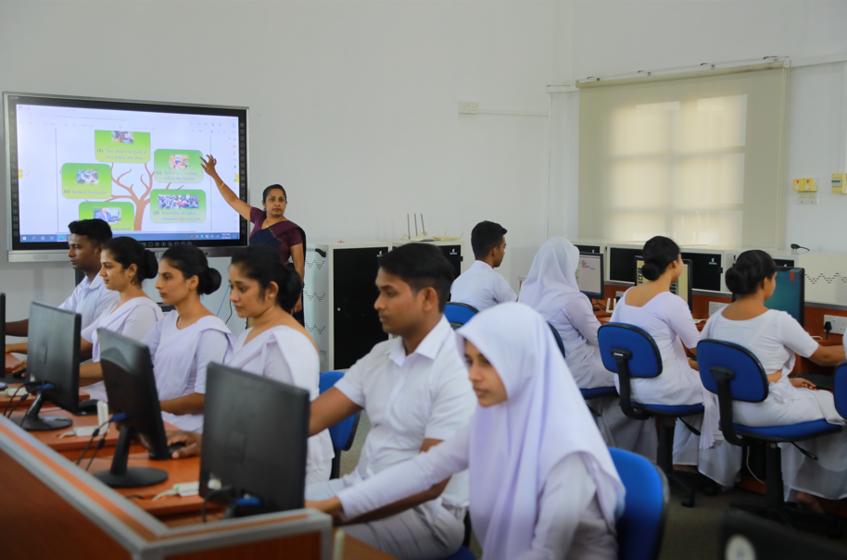
Figure 1:Captions are placed under the pictures. Ensure that your caption adequately describes what you want your reader to see in the picture, highlighting any areas that they should focus on or relationships that you might want them to see. [Caption].

Citations
The whole citation should follow the APA style, enclosed within parentheses (author surname, year) if not a natural part of the surrounding sentence; the year should be enclosed within parentheses if the names do form a natural part of the surrounding sentence. Citations of works by two authors should have ‘and’ (not an ampersand) between the names. Citations of works by three or more authors should have the first author followed by et al in italics with no trailing stop.
In-text lists of references should be listed in chronological order (e.g. author1, 2002; author2, 2004; author3, 2008). Publications by the same author(s) in the same year should be identified with a, b, c (e.g. 2008a, 2008b) closed up to the year.
When a cited work has three or more authors in the text, the form (main author et al. year) is used (Don’t forget to italicize et al.).
In accurate referencing authors encouraged to use citation management systems like Mendely or Endnote to adhere to APA style.
A reference list should appear at the end of the full paper under the heading "References". All the references should be arranged in alphabetical order.

